Foundations of Algebra in
High School

MATH5065
Bemidji State University

Meghan Brautigam
Edina High School
Meghan.brautigam@edinaschools.org

Executive Summary:
This unit focuses on ratios, proportions, measurement conversions, and direct and inverse variation. The unit starts with an introduction to ratios and then the students are introduced to proportional relationships. Students will be able to represent these relationships as equations and as graphs. Students will also be able to use ratios and proportions in real world contexts. The second half of the unit will involve measurements and the discussion of units. Students will start with making their own units, and then they will explore the Metric and English Systems and work on conversions within and between these systems. The unit will end with direct and inverse variation. Students will be able to recognize these relationships in graphs, equations, and tables.

Throughout this unit, it is assumed that students have some prior knowledge on linear equations. They should be familiar with the form y=mx+b and should be able to graph equations in this form. They are familiar with terms such as slope as the rate of change and y-intercepts. After this unit, students can move on to explore other relationships such as quadratic and exponential relationships.

My students in Edina are seated in groups of 4 or 5 students every day. They are all required to have a device such as a computer in class every day. I will be using this unit for my College Algebra Prep class. Even though these lessons are marked by “Days”, there is a possibility that some of these lessons may take multiple days, especially if more practice is needed.
MN State Standards:
- 6.1.2.1 Identify and use ratios to compare quantities
- 7.1.2.5 Use proportional reasoning to solve problems involving ratios in various contexts
- 7.2.1.1 Understand that a relationship between two variables, x and y, is proportional if it can be expressed in the form $\frac{y}{x}=k$ or $y=kx.$ Distinguish proportional relationships from other relationships, including inversely proportional relationships ($xy=k$ or $y=\frac{k}{x}$).
- 7.2.1.2 Understand that the graph of a proportional relationship is a line through the origin whose slope is the unit rate (constant of proportionality).
- 7.2.2.1 Represent proportional relationships with tables, verbal descriptions, symbols, equations and graphs
- 7.3.2.3 use proportions and ratios to solve problems involving scale drawings and conversions of measurement units
- 8.2.2.2 Identify graphical properties of linear functions including slopes and intercepts. Know that the slope equals the rate of change, and that the y-intercept is zero when the function represents a proportional relationship
- 9.2.1.8 Make qualitative statements about the rate of change of a function, based on its graph or table of values
- 9.2.4.8 Assess the reasonableness of a solution in its given context and compare the solution to appropriate graphical or numerical estimates
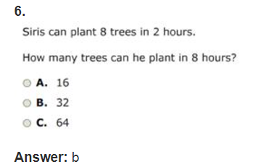
Sample MCA Questions:
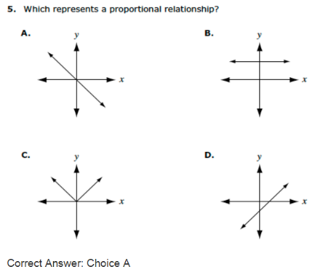
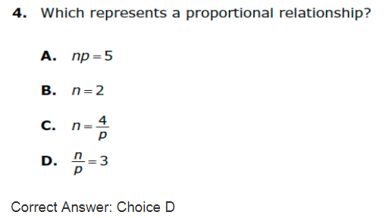

Table of Contents

Golden Ratio 4–7

Marcellus the Giant 8–9

Lemonade Stand 10 – 12

Graphing Proportional Relationships 13

How Much Sugar? 14–17

Capture/Recapture 18–22

Island Adventures 23–24

Conversions 25–29

Gimli Glider 30–31

Direct Variation 32–35

Inverse Variation 36–38

Direct and Inverse Variation Foldable 39–41

Direct and Inverse Variation Practice 42–44

Pre/Post Test 45–46

Day 1: Golden Ratio

Objective: Students will discover the golden ratio and see how it relates in nature
MN State Standards:
- 6.1.2.1 Identify and use ratios to compare quantities
Materials:
- Golden Faces Worksheet
- Rulers
Launch:
- Start with the Golden Ratio Notes to introduce the Fibonacci Sequence. This is from Smart Notebook software, but the general idea can be recreated.
- This should introduce the idea of the golden spiral, and they should see how it is used in nature.
- Show students the video Nature by Numbers: https://www.youtube.com/watch?v=kkGeOWYOFoA
- Students will be measuring parts of their bodies to try and figure out what the golden ratio is.
Explore:
- Hand out the Golden Faces worksheet. In this activity, students will work with a partner to find the measurements given on the worksheet. Some measurements may be hard with a ruler, but they should do their best. All estimates should be to the nearest millimeter for accuracy.
  - If students do not wish to have their own face measured, have printed copies of various celebrities for them to measure instead.
- Once students find all of their measurements, they will complete the back of the worksheet.
- This part of the activity has them find different ratios from their measurements. On this side, students should round to three decimal places if possible.
- The bottom of the worksheet explains that these values should be close to the golden ratio. Have students write down what they think the golden ratio is on their papers.
Share:
- Once everyone is done with their worksheet, have them find the average of their ratios (they should already have done this to estimate the golden ratio but some may have not).
- Then, take the averages for everybody and find a class average. Students should see that this number gets closer to 1.618, the Golden Ratio.
- Ask students why they think our number may not be exact.
  - Most likely students will respond with human error of measurement, and our bodies are obviously not perfect.
- Just like in nature, comparing certain measurements on our bodies also result in the Golden Ratio. It has been said that the more “beautiful” someone looks to our natural eye, the more golden ratios can be found on his or her face.
Summary:
- The main idea of this lesson is to give students an understanding of how ratios work. A ratio can be written as a fraction or decimal, and it is comparing two quantities.
- Finally, show students the video on someone taking a photo of a woman and using Photoshop to change the face using the Golden Ratio.
  - This video is found at: https://www.youtube.com/watch?v=KeAm1cc9lIM

Golden Ratio Notes
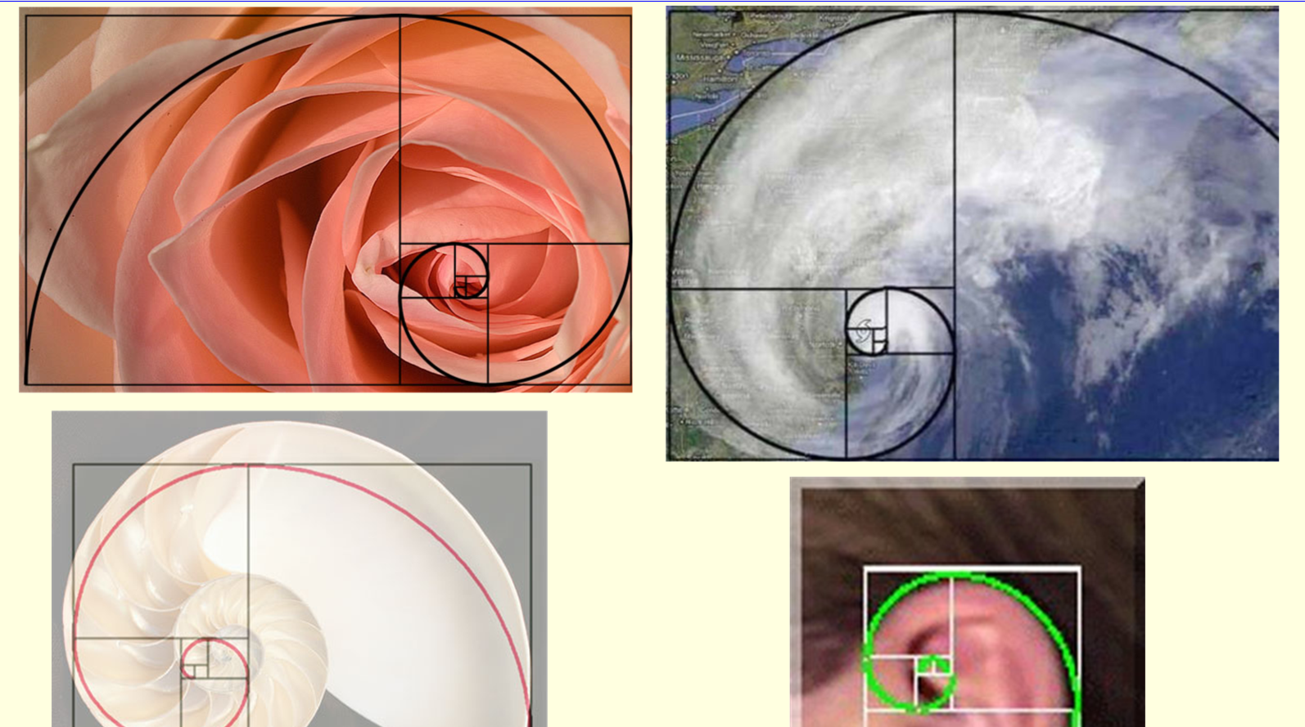
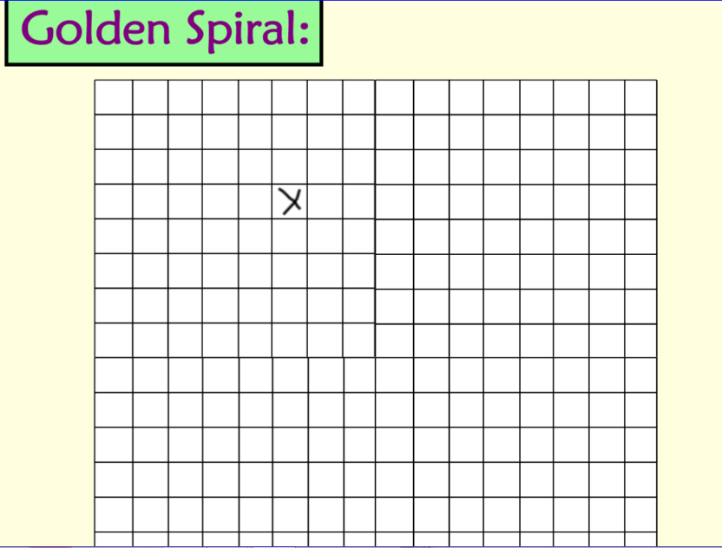
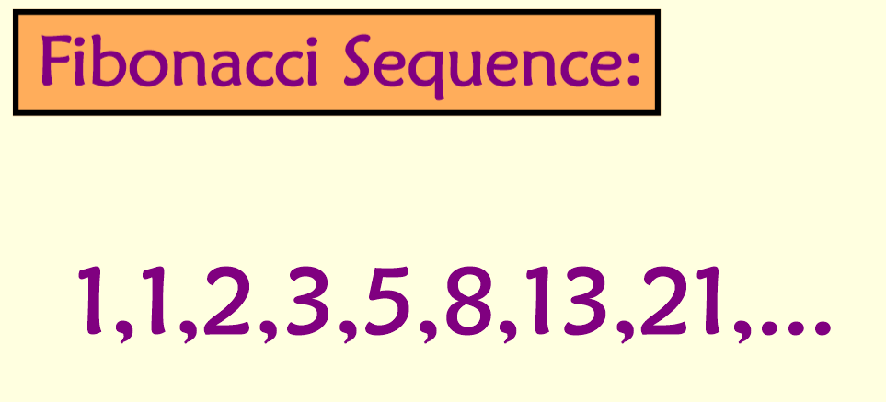
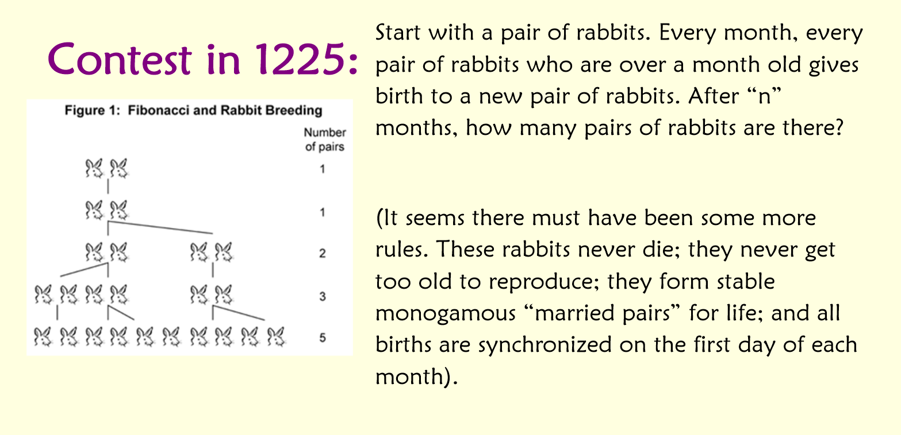
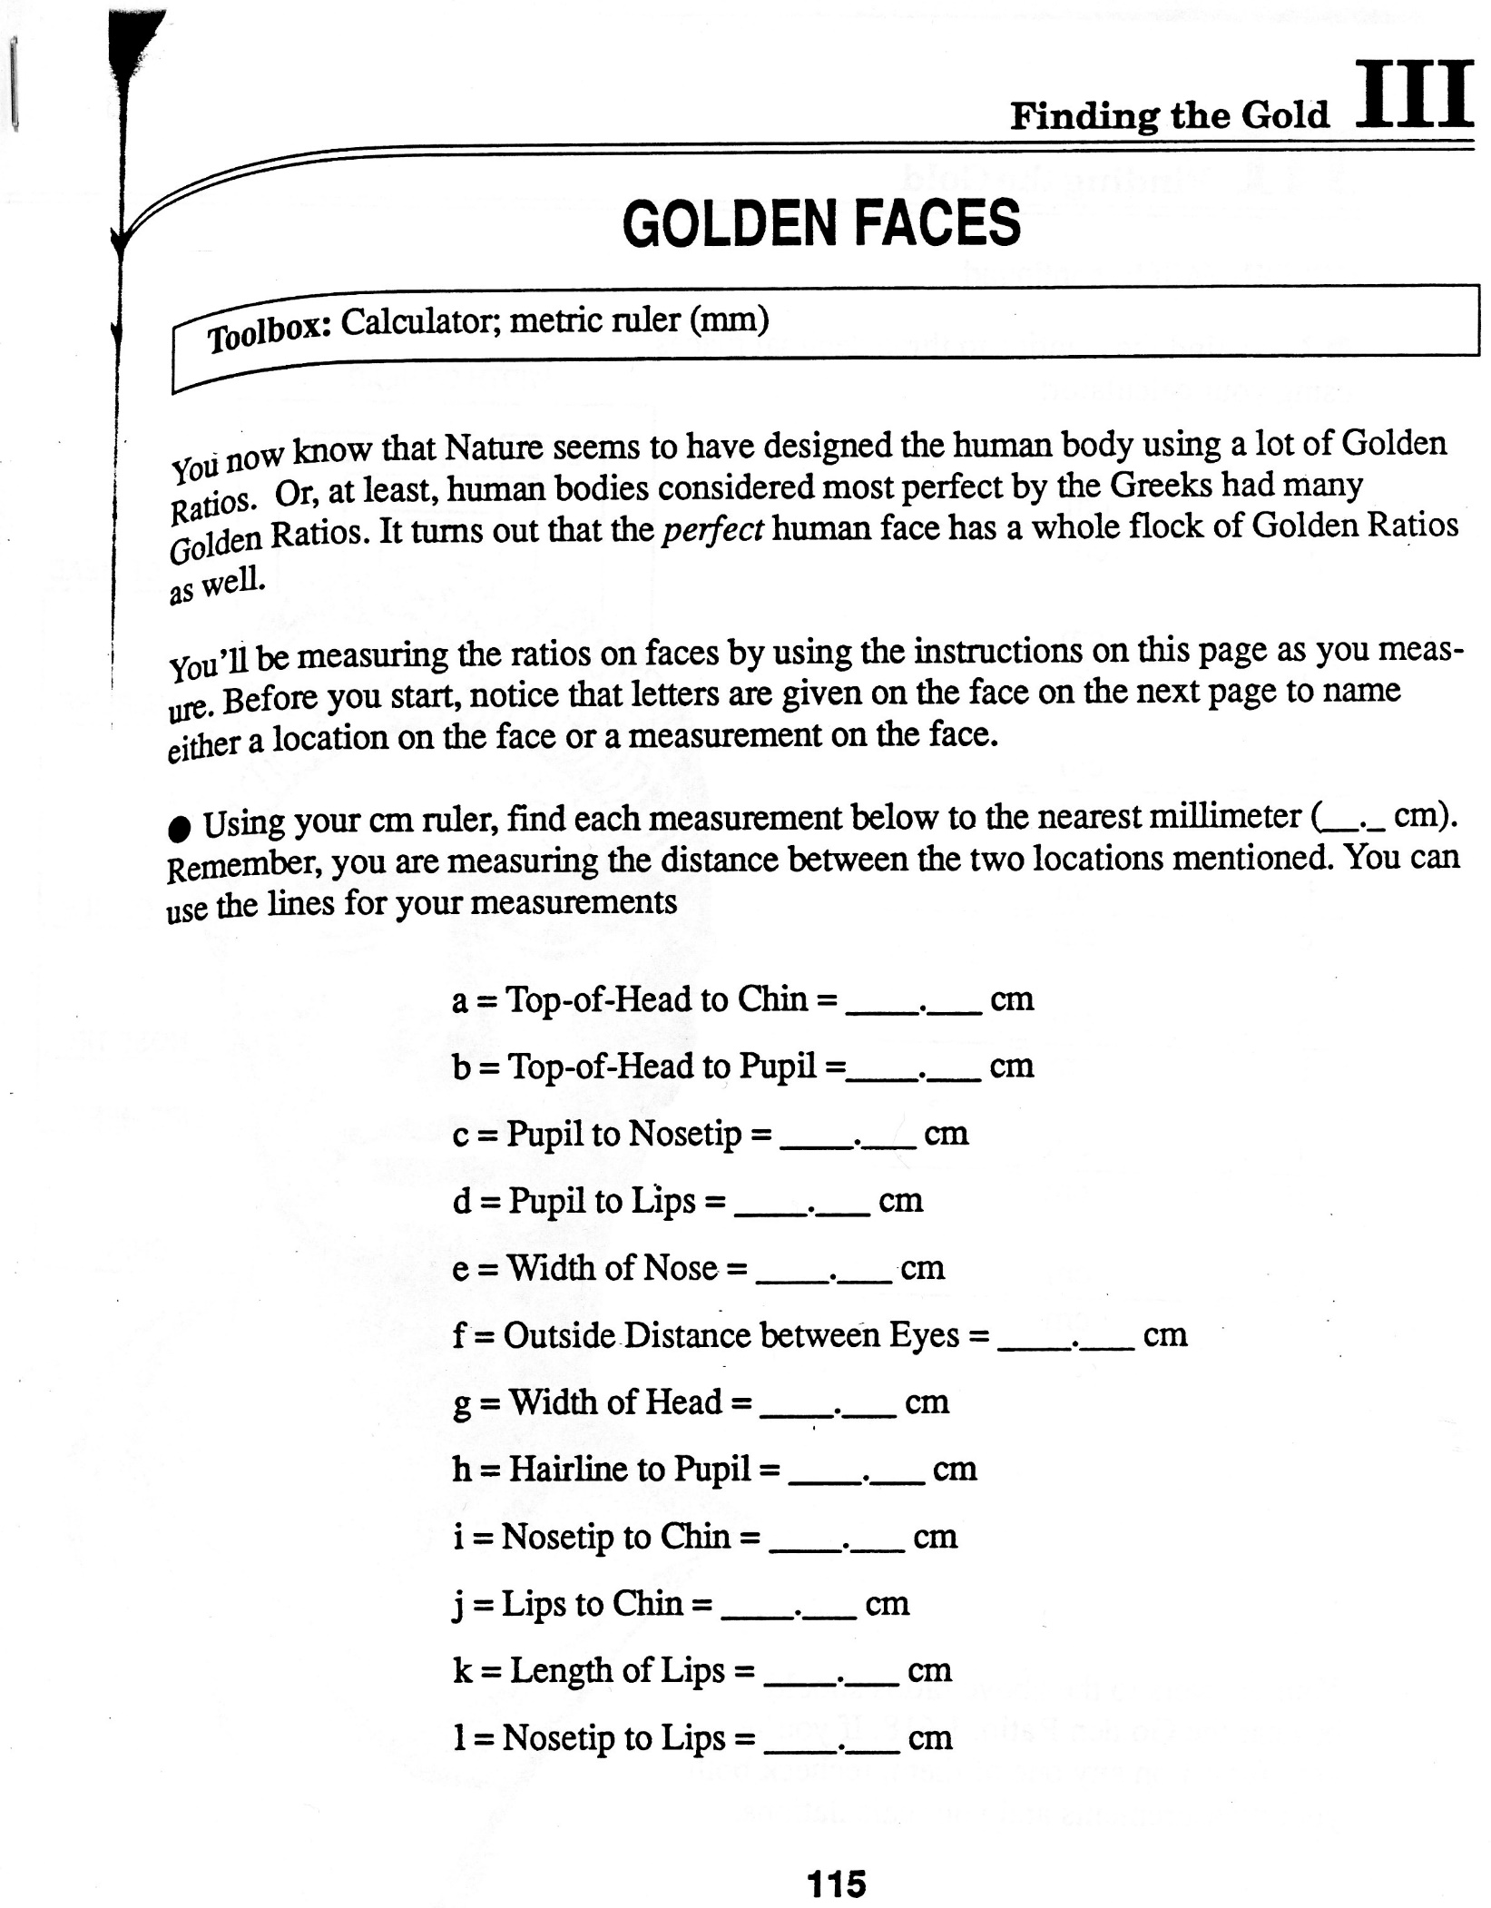
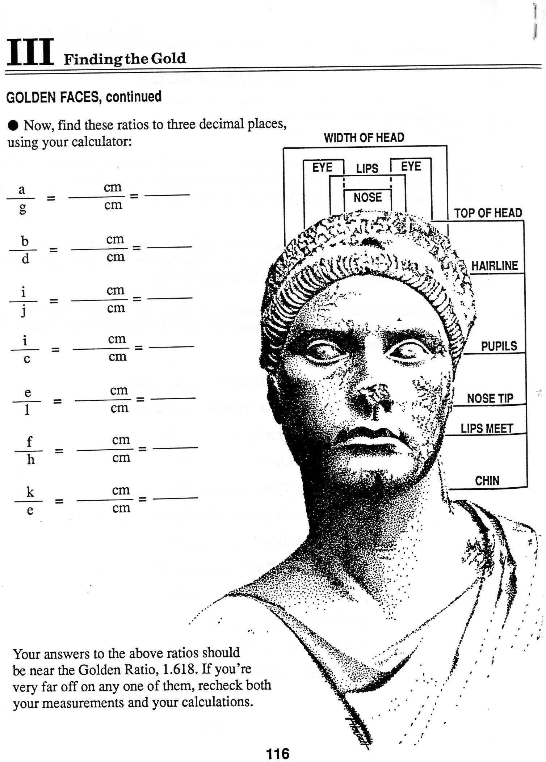
Day 2: Marcellus the Giant on Desmos

Objective: Students will use technology to understand proportional relationships
MN State Standards:
- 7.2.1.1 Understand that a relationship between two variables, x and y, is proportional if it can be expressed in the form $\frac{y}{x}=k$ or $y=kx.$
- 7.3.2.3 use proportions and ratios to solve problems involving scale drawings and conversions of measurement
- 8.2.2.2 Identify graphical properties of linear functions including slopes and intercepts. Know that the slope equals the rate of change, and that the y-intercept is zero when the function represents a proportional relationship
- 9.2.4.8 Assess the reasonableness of a solution in its given context and compare the solution to appropriate graphical or numerical estimates
Materials:
- Students will need their device (iPad or laptop)
Launch:
- Ask students where they have seen scale factors, or models, in their lives.
  - Some examples include model cars, maps, and architecture designs.
- Ask them what they know about the relationship between the model and actual object.
  - They should understand that everything is increased or decreased by a scale factor if the model is to truly represent the original object.
Explore:
- Have students log onto Desmos using the appropriate class code (student.desmos.com). They will be completing Marcellus the Giant.
  - At any point, if it seems like students are not understanding, freeze their screens and explain any misunderstandings. This will help students get caught up and stay on the right track.
- This activity starts with showing examples of scale giants and non-examples of scale giants. Then it asks students to define in their own words what it means to be a “scale” of another giant.
- Then students create a scale giant. The students pick a scale and then have to figure out the measurements of different parts of the giant.
- Finally, students look at a graphical representation of a scale factor. They must match the different parts on the graph to make a scale giant. The original dimensions are along the x-axis, the giants dimensions are on the y-axis, and the slope of the line is the scale factor.
Share:
- Throughout the activity, students should be working with their neighbors if they have any questions while going through the activity.
- The last slide of the activity has students add an accessory to Dan and the giant. Students should draw the accessory and then explain to their neighbor how they know it is proportional to Dan.
Summary:
- Students should recognize that a proportional relationship can be written as y/x = k or y=kx. The scale factor k (or constant of proportionality) is equal to the ratio of the two numbers you are comparing.
- Students should understand that a ratio is just the fraction, while a proportion is made up of a ratio equal to a scale factor. We will be using proportions to help us solve problems in the next few lessons.

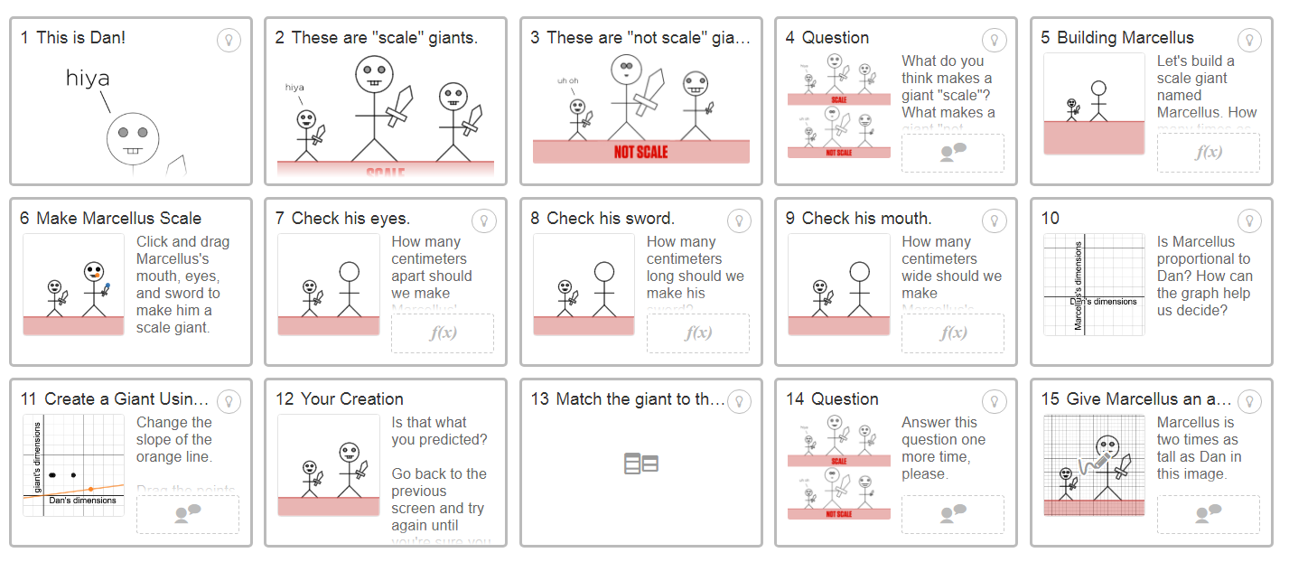

Day 3: Lemonade Stand

Objective: Students will be able to use ratios and pictures to answer real world questions
MN State Standards:
- 9.2.4.8 Assess the reasonableness of a solution in its given context and compare the solution to appropriate graphical or numerical estimates
Materials:
- Lemonade Stand worksheet
Launch:
- Ask students how many of them have ever had a lemonade stand as a child or if they have ever bought lemonade from a home lemonade stand.
- Ask them if they remember how to make lemonade. How much water gets put it? How much lemonade mix? Do they like their lemonade to taste more lemony or more watery?
Explore:
- Hand out the Lemonade Stand worksheet. There are four different recipes for lemonade on the worksheet.
- The students will work in their groups to determine which of the four recipes will taste the most lemony. They have learned about ratios the previous day, so they can choose to use ratios or a picture if it helps.
  - Students should get to choose how they solve the problem with no direction on any sort of method initially.
- Using this same logic, students can also determine which recipe will be the least lemony.
- Students should create a mini presentation on their answer that shows how they got to their final conclusions.
Share:
- Before they answer the third question, students should present their work to the class. Each group should share their work along with an explanation. Students should see that this problem can be solved in many ways:
  - For example, using ratios either part to part or part to whole, drawing a picture to represent the problems, converting to percentages, etc.
- Even if students did not solve the problem using ratios, they should make note of how this problem can be solved using ratios because that is the overall objective of the lesson.
Explore:
- The third question on the worksheet has students figure out how much lemonade powder and how much water they would need to sell 120 cups of lemonade.
  - Students will first need to figure out how many total cups each recipe makes. Then they will need to divide that from 120. This becomes their constant of proportionality. They should then use this constant to figure out how many cups of lemonade mix and how much water they need per recipe.
Summary:
- A discussion of this problem will continue on the following day. Students should make sure they have work to show how solved the last problem and if they did not have time to finish they will continue the following day.

Adapted From CPM
http://teresaemmert.weebly.com/uploads/1/3/0/5/13053448/orange_juice_problem.pdf

Lemonade Stand

You are trying to make money by selling lemonade in your neighborhood. You go to the store to pick up some lemonade mix. The package of mix provides four different recipes on the back:

Recipe A  3 cups lemonade mix  5 cups water | Recipe B  2 cups lemonade mix  4 cups water
Recipe C  5 cups lemonade mix  7 cups water | Recipe D  2 cups lemonade mix  3 cups powder

- Which recipe will taste the most “lemony”? Justify your answer below.

- Which recipe will taste the least “lemony”? Justify your answer below.

- You anticipate selling 120 cups of lemonade your first week. For each recipe, how many cups of lemonade mix and how many cups of water will you need to sell 120 cups of lemonade?

- Think back to Marcellus the Giant. Below is a graph representing Marcellus and Dan when Marcellus is two times as big as Dan. What observations do you notice about the graph?
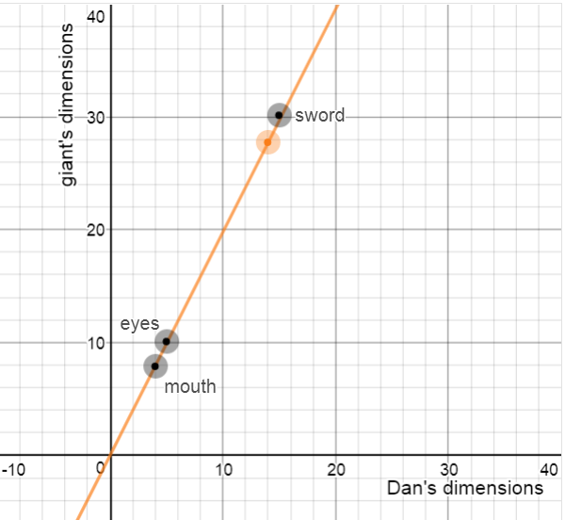

- Now we are going to plot our lemonade data comparing our original recipes to the recipes from question three. Each recipe should create a different line when we plot them all on the same coordinate plane. Our axes, however, should be the same in all four cases. What should the x-axis be labeled? What should the y-axis be labeled?

- The slope of each line will be different. How do we find the slope of each line (or each recipe)?

- Notice how points on the line in the graph above indicate what the measurement of the eyes, sword and mouth are. What points will you have on each of your lines for this problem?

- Sketch a graph of your four recipes on the same coordinate plane. Make sure you label the different parts of your graph. Label each graph with an equation to represent each recipe.

Day 4: Graphing Proportional Relationships

Objective: Students will graph proportional relationships using previous knowledge of y=mx+b
MN State Standards:
- 7.2.1.2 Understand that the graph of a proportional relationship is a line through the origin whose slope is the unit rate (constant of proportionality).
- 9.2.1.8 Make qualitative statements about the rate of change of a function, based on its graph or table of values
- 9.2.4.8 Assess the reasonableness of a solution in its given context and compare the solution to appropriate graphical or numerical estimates
Materials:
- Lemonade Stand packet from previous day
Launch:
- Have students complete the third question from the Lemonade Stand packet from the previous day. If groups already finished, have them go over the problem in their group so that they remember their process from the day before.
- Students will then share their answers. Each group should come up with the same answer, so groups should take turns sharing their methods if they did it differently than the previous group. Before moving to the next step, students need to make sure they have the correct numbers.
Explore:
- Students will be completing the back of the worksheet by discovering how to graph their information. They will be comparing their original recipes to their recipes that serve 120 cups.
- Students should recognize that the 120 cup recipe is just a scale factor of their original recipes. The number found in the third question on the worksheet when they took 120 divided by total cups in the recipe becomes their constant of proportionality.
- Students will work together to finish the worksheet. When they are done, students will present their graphs to the class. Students should have prior knowledge on graphing a linear equation.
- The main points of this worksheet that students need to know are:
  - The axes are what you are comparing. In our case the x-axis should be our original recipe (in cups) and the y-axis should be our 120-cup recipe.
  - The slope for each line will be the constant of proportionality in each recipe found in question 3.
  - The dots that should be on each line are lemonade mix and water because these are what we are changing.
  - The equations of each line should be y = kx + 0, where k is the constant of proportionality and the y-intercept is 0.
Share:
- Groups will take turns sharing their graphs. Because there was no graph provided, students may have sketched it differently or scaled their axes differently. In general, the graphs should look similar.
- Ask: Can my graph go into the negatives? Why is my y-intercept 0? Why do all our graphs look similar? Why do our graphs look like straight lines?
Summary:
- By the end of the lesson, students should realize that a proportional relationship is linear because everything changes at the same rate. The slope of the line is the constant of proportionality and your axes are what you are comparing. You can denote specific quantities or measurements that you are changing by putting dots on the line. Because these are linear, students can use y = mx + 0 to help find an equation to represent the graph.
Day 5: How Much Sugar?

Objective: Students will use proportions to solve a real world problem
MN State Standards:
- 7.1.2.5 Use proportional reasoning to solve problems involving ratios in various contexts
- 7.2.2.1 Represent proportional relationships with tables, verbal descriptions, symbols, equations and graphs
- 7.3.2.3 use proportions and ratios to solve problems involving scale drawings and conversions of measurement units
Materials:
- Dan Meyer Three Act on Sugar Packets - http://threeacts.mrmeyer.com/sugarpackets/
- Various beverage items with different amounts of sugar.
  - Examples can be regular soda, diet soda, different types of juice, milk, gatorade
Launch:
- Show students Act One from this Three Act lesson.
  - Video can also be found at: https://www.youtube.com/watch?v=yK1kkAoFeVQ
Explore:
- Have students brainstorm guesses to the following and share them.
  - How many sugar packets are in a 20-oz bottle of soda?
  - What is a number that is too high?
  - What is a number that is too low?
  - What additional information do we need?
- Once students have given adequate guesses for Act One, provide them with the information for Act Two.
  - Found at: http://threeacts.mrmeyer.com/sugarpackets/act2/cocacolainfo.pdf
  - Found at: http://threeacts.mrmeyer.com/sugarpackets/act2/sugarinfo.png
  - These are also attached below
- Now that students have more information, they should be able to figure out how many packs of sugar are in a 20-oz soda by setting up a proportion.
Share:
- Students will work in their groups to come up with an answer. Once they have an answer, all groups will write their answers on the board along with their work.
- Groups who used different strategies or methods should explain to the class what they did to solve the problem.
- Finally, reveal the answer with the Act Three.
  - Video can also be found at: https://www.youtube.com/watch?v=N4e_fzfwj2c
Explore:
- Next, students will go around the room finding the different amounts of sugar packets in each bottle provided by the teacher. They should be keeping track of the type of beverage, the size of the bottle, and the number of sugar packets in each bottle.
  - For each beverage, they should have a proportion and work shown on how they solved each problem.
- Students should keep track of this information in a table of values. They will need it tomorrow.
Summary:
- The goal of this lesson is for students to be able to use the ratio of 4 grams of sugar per 1 packet. They can set up a proportion when you know there are x amount of grams of sugar in a beverage. We will be using this information the following day.
Adapted from Math = Love and Dan Meyer Three Acts at
http://mathequalslove.blogspot.com/2012/04/sugar-packets-and-proportions.html

Day 6: How Much Sugar? Day 2
Objective: Students will use data points to analyze and draw conclusions about its graph
MN State Standards:
- 7.2.2.1 Represent proportional relationships with tables, verbal descriptions, symbols, equations and graphs
- 9.2.1.8 Make qualitative statements about the rate of change of a function, based on its graph or table of values
- 9.2.4.8 Assess the reasonableness of a solution in its given context and compare the solution to appropriate graphical or numerical estimate
Materials:
- Bottles from the previous day
- Student data from previous day
Launch:
- Ask: How many sugar packets are in a case of Mountain Dew? A 12 oz. can of soda has 9 grams of sugar in it. Students should set up a proportion and solve.
  - Total grams: 9 x 12 = 108 grams, divided by 4 grams per packet = 27 packets of sugar.
  - This relates to the story about the guy who drank almost two cases of Mountain Dew in two days without realizing it.
Explore:
- Have students get out their data from the day before. They should have a table with the number of ounces in each beverage with the number of packets of sugar in each.
- Students should then come up with a graph of their data.
  - They need to determine what the x-axis should be, what the y-axis should be, give their graph a title, and plot their points.
  - Students should come up with an equation for their graph if they can. They should see if there are any linear or other patterns in the graph.
Share:
- Groups will take turns sharing their graphs. They should identify what their axes are and if they were able to come up with an equation for the graph.
- Once students have had a chance to share their graphs ask:
  - Since each beverage uses the same constant of proportionality (4 grams = 1 packet), should my graph be linear? In other words, would every 20 oz bottle of any beverage contain the same amount of sugar?
    - Also ask what causes the “shape” or look of the graph to be linear or nonlinear?
  - Is this a function? This will depend on whether or not there were bottles with the same amount of ounces and different amounts of sugar.
  - Would I be able to switch what’s on my x-axis and what’s on my y-axis? In other words, does it matter which variable is my dependent variable and which is my independent?
  - Should I connect the points on my graph? Is it possible to know how much sugar is in 10.5 oz of a beverage?
Summary:
- Students should understand that this is not necessarily linear because the number of ounces in a beverage does not necessarily predict the amount of sugar in a beverage. For example, a 20 oz bottle of soda will most likely have more sugar than a 20 oz bottle of milk.
- They should be able to use ratios and proportions to find missing values.
- Finally, they should be able to represent this information from a table onto a graph and interpret the results.

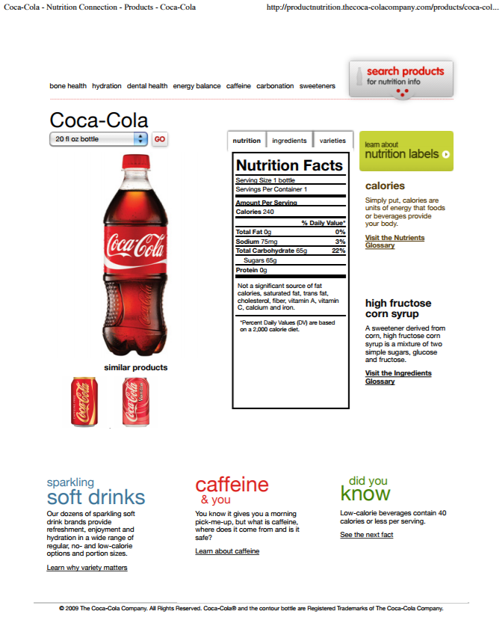

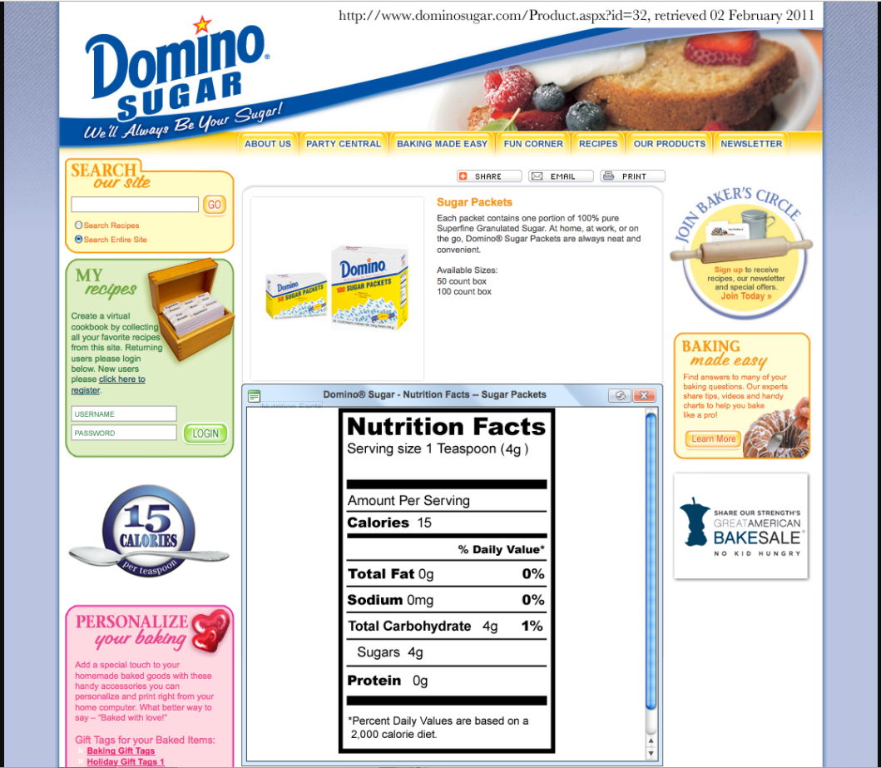

Day 7: Capture/Recapture

Objective: Students will use ratios and proportions to estimate a population based off of a sample
MN State Standards:
- 7.1.2.5 Use proportional reasoning to solve problems involving ratios in various contexts
- 9.2.4.8 Assess the reasonableness of a solution in its given context and compare the solution to appropriate graphical or numerical estimates
Materials:
- Capture/Recapture – Proportions Math Activity packet
- Brown paper bags
- Dixie cups
- Napkins/paper towels/paper plates
- Regular Goldfish
- Rainbow Goldfish
Launch:
- Ask students how many students they think are in Edina High School.
- Then, tell them how many students are in their class. Assuming there are 85 classes, how many students do they now think are in Edina High School.
  - Students should estimate about 85 times the number in the class.
- Students will be using this estimation of an entire population from a sample population in the following activity.
Explore:
- Hand out all of the materials. Students will work with their groups on the capture/recapture activity. Students should have a packet, a brown paper bag with regular Goldfish, and a dixie cup. They should not know how many Goldfish are in their bag.
- Students will take a scoop of Goldfish out of their bag. Students will count them. These fish are now “tagged”, so they will replace them with rainbow Goldfish.
- Students will put the rainbow Goldfish in the bag and shake it. Then they will take another scoop out of the bag. They will record the number of total fish in the scoop and the number of rainbow Goldfish in the scoop.
- They will use these numbers to try and estimate the total number of Goldfish in the bag. They can set up a ratio of rainbow Goldfish to total Goldfish in the scoop to the number of tagged Goldfish to total Goldfish.
- Finally, they will count their Goldfish to see how accurate their estimates were.
Share:
- Students will share their predictions and actual total to the class. Each group should share so we can see if this is a good way to estimate population.
- Ask students in the real world, is this a reasonable way to estimate a population.
- Ask students if they can think of any other ways to estimate the population of a species.
- Ask students what may contribute to a bad estimate using this method.
Summary:
- By the end of this lesson, students should have a better understanding of how proportions and ratios work. In this particular case, they are taking the ratio of tagged Goldfish to total Goldfish in the sample (in the cup) and setting it equal to the ratio of total tagged Goldfish to total Goldfish in the bag.

Capture/Recapture – Proportions Math Activity

The idea behind capture and recapture is how environmental agencies and other researchers estimate populations of animals in a variety of habitats.

What is capture-recapture:
- Capture and tag some animals in their natural habitat, allowing each animal to go free after being tagged.
- Recapture a sample of animals randomly from their habitat and count how many from that sample are tagged out of the total number of animals captured in the sample.
- Use the proportion to estimate the total population of animals in the habitat. Write the ratio of tagged animals in your sample to the total number of animals in your sample. Then write the ratio of the number of animals originally tagged to the unknown estimated total population.

The estimate is based on the assumption that the ratio of the number of tagged animals to the number of animals caught in the sample is nearly the same as the total number of tagged animals to the total population in the habitat.

$$\frac{Number of tagged animals in sample}{Total number in the sample}=\frac{Number of tagged animals in the population}{Total number in the population}$$

Example:

In a capture-recapture study, 60 deer are tagged. On the recapture, 52 deer are caught with only 9 of those 52 having tags. Estimate the total number of deer in the forest. Write and show a proportion.
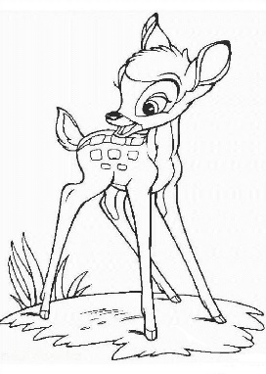

- Do you think this is a good way to estimate a population? Why or why not?

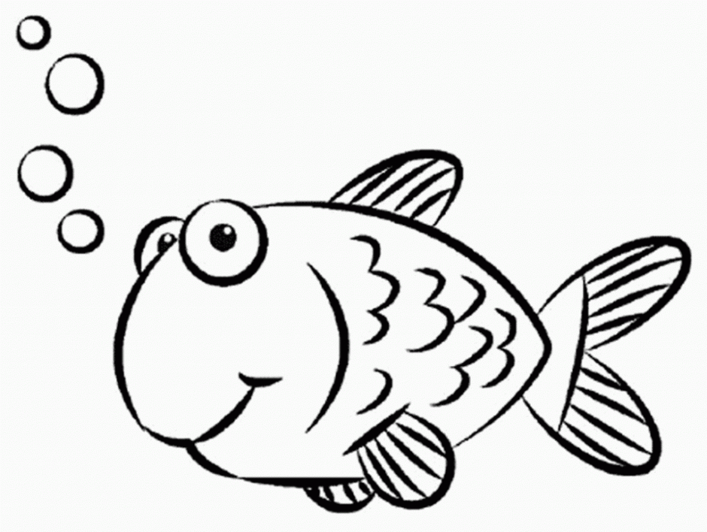
Objective: You are a park ranger and are assigned to keep a specific pond clean and stocked. Your job is to determine how many fish are in your pond to decidee if it needs to be restocked. Use a capture-recapture strategy to set up a proportion that will allow you to estimate the number of fish in your pond.

Materials (per group):
- Capture/Recapture – Proportions Math Activity Worksheet
- Writing utensil
- Calculator
- 1 paper bag
- 1paper towel
- 1 dixie cup
- 3 dixie cup scoops of regular goldfish – dump these into your brown bag
- 1 dixie cup scoop of colorful goldfish – keep these off to the side on your desk

Activity:
- Send one person from your group up to the front to grab all of your materials. Make sure you have your goldfish in the correct spots.

- Your brown bag represents your pond. It is filled with a population of regular goldfish. Using your dixie cup, take a scoop of goldfish from your pond. These are the fish captured that you will tag.

Number of tagged fish in your population = _________________

- Replace those regular goldfish with the same amount of colorful goldfish. Put the colorful goldfish in your pond and leave the regular goldfish out. You have now just completed the capture and tag portion of this process. Shake your bag carefully to allow your fish to swim around for a few days.

- Without looking into the bag, RECAPTURE a cup full of fish. Count the total number of fish that you’ve captured and the number of fish that were tagged.
Total number recaptured = ________________
Number of recaptured fish that were tagged = _______________

- Use your numbers to set up your proportion like the one below. Solve for p and round to the nearest whole fish.
$$\frac{Number of tagged fish in sample}{Total number in sample}=\frac{Number of tagged fish in population}{p}$$

Your population estimate for sample #1 = ____________________

- Record your results from trial #1 in the table below. Complete 4 more trials using the same number of tagged fish.

Trial | Total Number in Recapture | Number Tagged in Recapture | Population Estimate
1
2
3
4
5

- Calculate the mean for the population estimate for the 5 samples.

Estimated mean population = _______________________________

- Count the total number of fish in your pond and compare the number to your estimate.

Actual population = _________________________________

- How close was your estimate? Find the difference between the actual number and your estimate.

Difference = _______________

Go ahead and eat your fish while answering the following questions.

- How do proportions help to find the total number of fish in the pond?

- What might happen if only a small number of fish are tagged?

- Why was it important to complete more than one trial?

- After completing this process, do you believe this is a good method for estimating population? Can you think of any other methods that may work?

Day 8 and 9: Island Adventures
Objective: Students will create their own unit of measurement using logic and reasoning
MN State Standards:
- 7.3.2.3 use proportions and ratios to solve problems involving scale drawings and conversions of measurement units
Materials:
- Poster paper
- Coloring utensils
Launch:
- Ask students what the best unit of measure is. Why do they think it is the best unit of measurement? Where did it come from? Why is a foot called a foot?
- Break students into groups of four. Tell them that they are travelers from hundreds of years ago that are sailing on a ship and come across a deserted island. Students are going to become the experts of the island, so they need to know how everything works. The only resources on the island are those that are specific to the island. Before further instruction, have them come up with an island name.
Explore:
- Based off of the name of their island, they will have a theme. Students should assume their island has available only what can be produced on the island, but they can get creative in what their island offers.
- Students will be creating their own unit of measurement on their island. The unit of measurement should be unique to their island. It should not be inches, feet, meters, etc. Their unit of measurement should be related to their theme, and it should be something that can be found/made on the island.
  - Students should keep in mind how they plan on measuring large and small objects. Can they measure ½? ¼? Can they convert to different units to measure large or small objects?
  - Does the measuring device cost money? How do they obtain a measuring device?
- Once students have their measurement created, they should use their unit of measurement to measure a desk, a pencil, and the length of the wall.
- Students will be creating a poster explaining their island, what their unit is, any conversions, costs, or accessibility information. They should also include the measurements they found for the desk, pencil, and wall to show examples of how their units work.
- At the end of the two days, students will be voting on which island they want to live at based on the presentations. Essentially, students should be selling their island to their classmates.
  - Encourage creativity! Their units should be something unique with a good explanation for why it works on their specific island.
Share:
- Groups will take turns sharing their posters. During the presentation, students should advertise their islands based off of the information on their poster. They are trying to convince why their island is the best based off of the unit of measurement.
  - If possible, they should physically show what their unit of measurement looks like.
  - The teacher should constantly be challenging their unit asking how it measures really small or really large items. How do they measure half a unit? Do they have to just estimate or is there a good way to do this.
- Once all groups have had a chance to share their islands, the class will vote on which island they think is the most reasonable based off of the presentations.
  - Have different students justify why they are voting for a particular group over another.
Summary:
- The purpose of this activity is to get students thinking about measuring using any type of unit. Students are familiar with measuring in inches, centimeters, feet, etc. but why do we use these measurements? What do they mean in terms of size?
  - Everything is dependent on what unit we are considering. For example, centimeters are great if you are measuring small items, but what if we wanted to measure a large item? Would we still want to use centimeters? Students should realize through this the importance of having unit conversions.
  - Also, students should realize the significance of having partial or fractional units. If we just had a foot stick with no partial measurements, we would have to estimate everything in between. Students should see that in order to be accurate in our measurements, we need to be able to measure our fractional or decimal values.
  - Accessibility to measurement is also another factor. Most of us have rulers on hand, but what about on an island. If resources were minimal, how easy would it be to get something measured? Will the measurements be consistent throughout the island or will it depend on different factors such as who is measuring?
  - If our unit of measurement is small, how can we measure large items? Students should realize that you could measure a larger item with their unit of measurement and then use this as a scale factor to measure the larger items with this new larger unit.
- The following examples below show some of the creativity that can be used, and it shows potential successes or challenges a certain unit can have.
- Finally, end with asking students again what they think the most convenient form of measurement is that we use in our lives today. Why do they think it is convenient? Hopefully they can provide answers that deal with accessibility, ability to measure large and small, and easy conversions.
- Let them know that the following day they will be learning how to convert different units.
Examples:
- When I completed this activity, we used hands to measure on our island. We used parts of our fingers as partial units. Our selling point was that it was free because everyone has hands, so they will always have access to their measuring tool. The bad part was that everyone has different size hands so there would be inconsistencies in measurements (our teachers used the example of building a house and needing certain wood measurements. The measurements I give to the contractor may be different than the measurements I got back because of hand sizes). We ended up modifying our measurement to say we could measure in large, medium, small, and kid size hands.
- Another group used an ankle bracelet as their unit of measurement. They claimed that they would make these for people on the island and the cost around $9.99. They were all the same size and it even had little beads at the ½ and ¼ marks to measure fractional parts. They did not really have an efficient way to measure large quantities. They could see how many bracelets make up the wall for example and then use the wall as measurement.
- A third group used a notebook. This was convenient because they claimed notebooks grew in the bushes so they were always accessible. There were also 18 rings on the notebook, so they could measure 1/18 increments.
- A final example is a group who used conversions. They used feet and toes. They figured out about how many toes equaled a foot, so this is how they measured small units, and then they compared their feet to their leg and made this conversion to measure large objects.

Adapted From a lesson by Craig Rypkema and Glen Richgel’s
Day 10: Conversions
Objective: Students will be able to convert within and between the English and Metric Systems
MN State Standards:
- 7.3.2.3 use proportions and ratios to solve problems involving scale drawings and conversions of measurement units
- 9.2.4.8 Assess the reasonableness of a solution in its given context and compare the solution to appropriate graphical or numerical estimates
Materials:
- Conversion Activity worksheet
- Students will need their device (preferably computer but a phone will work)
- Rulers
- 2-liter soda
- Liquid beverage in a bottle
Launch:
- Ask students to estimate how long a football field is in yards. Then ask them to estimate how many feet that is. Then ask them to estimate how many inches that is. Do the same thing with meters, centimeters, and millimeters.
- Ask them if they know the difference between the two systems (English and Metric). Why do we choose to use one over the other?
Explore:
- The classroom should be set up in six stations (you could double the stations if there are a lot of groups). The six stations are:
  - “Length – Metric System” with a ruler and desk
  - “Length – English System” with a ruler and a door
  - “Capacity – Metric System” with a 2-liter soda
  - “Capacity – English System” with a liquid beverage measured in ounces
  - “English and Metric Equivalents” with their device
  - “Temperature” with their device
- Hand out the Conversion Activity worksheet. Students should be broken up into six groups. They will be given 7 minutes at each station.
  - At each station they must answer the questions on their worksheet from the station. They should include the work to all of the questions. This worksheet will act as part of their notes because they will discover different conversions throughout the activity.
  - To do this, as a group they will need to measure items or look up measurements on their device. Then, they will need to use their device to figure out various conversion rates. Finally, they will use the conversion to set up a ratio and answer the questions.
Share:
- Some students may know some of the conversions already, but if they don’t know how to convert something they need to be able to work with their group members to figure out the conversions.
- Once students have completed the activity, they can check their answers on the board so that they can go back and fix any mistakes before the end of class.
- Most of the sharing will occur the following day at the beginning of class.
Summary:
- This lesson will take most of the hour, so more discussion will take place the following day. For today, students should be familiar with converting between units when they know the conversion rate.
Conversion Activity

Length – Metric System:

Length – English System:

Capacity – Metric System:

Capacity – English System:

Metric and English Equivalents:

Temperature:

Length – Metric System

- Measure the length of the desk in centimeters.

- How do you convert centimeters to millimeters?

- What is the length of the desk in millimeters?

- How do you convert from centimeters to meters?

- What is the length of the desk in meters?

Length – English System

- What is the height of the door in feet?

- How do you convert feet to inches?

- What is the height of the door in inches?

- How do you convert feet to yards?

- What is the height of the door in yards?

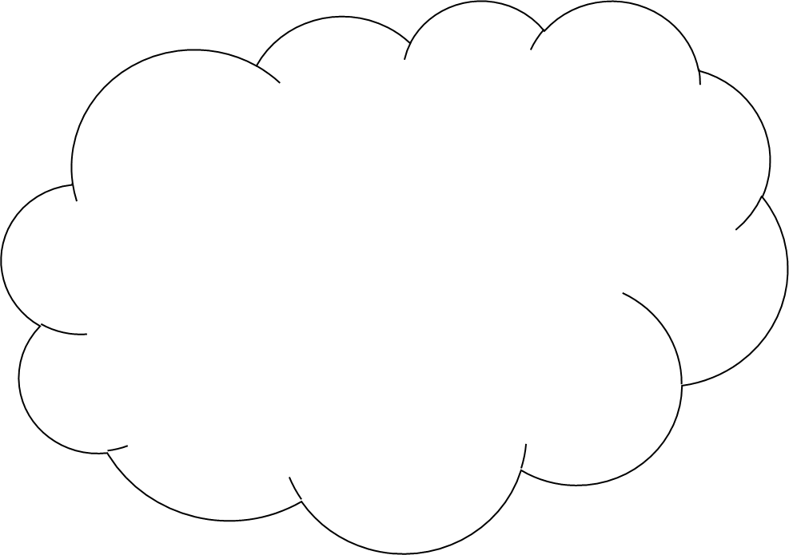

Capacity – Metric System

- How many liters of soda are in the container?

- How do you convert liters to milliliters?

- How many milliliters are in the container?

- How do you convert liters to kiloliters?

- How many kiloliters are in the container?

Capacity – English System

- How many ounces are in the bottle?

- How do you convert ounces to cups?

- How many cups are in the bottle?

- How do you convert ounces to gallons?

- How many gallons are in the bottle?

Metric and English Equivalents

- Find the length of an iPhone 7 in inches.

- How do you convert from inches to centimeters?

- What is the length of an iPhone 7 in centimeters?

- Find the weight of the world’s largest pizza in pounds.

- How do you convert pounds to kilograms?

- What is the weight of the largest pizza in kilograms?

Temperature

- What is the temperature outside right now in degrees Fahrenheit?

- What is the formula for converting Fahrenheit to Celsius?

- What is the temperature outside right now in degrees Celsius?

- What is the temperature in Paris in degrees Celsius?

- What is the formula for converting Celsius to Fahrenheit?

- What is the temperature in Paris in degrees Fahrenheit?

Day 11: Gimli Glider

Objective: Students will apply conversions to a real life crisis situation
MN State Standards:
- 7.3.2.3 use proportions and ratios to solve problems involving scale drawings and conversions of measurement units
Materials:
- Students will need their Conversion Activity from the day before
- Gimli Glider video: https://www.youtube.com/watch?v=iFVSboyJ_nE
- Smart Notebook Presentation on the Gimli Glider
Launch:
- Students should take out their worksheets from the day before. Class will start with a discussion on what they found the previous day.
  - First ask students about any observations they noticed. Were some conversions easier than others? Are there units you would prefer to use over another? Why do you think most of the world uses the metric system? Should the whole world be consistent with the measurements we use? What complications may we face if we don’t use consistent measurements? Would it be possible to only use one unit of measurement for everything or are conversions necessary?
- Once students have had a chance to discuss the importance of being able to convert between different units, explain how conversions work in case any students were still struggling.
  - Converting can be written as ratios. The key is to start with your measurement divided by 1, and then you multiply by the conversion by keeping the unit you want on top and the unit you are trying to get rid of on bottom.
    - For example, converting 3 inches to feet = $\frac{3 inches}{1}×\frac{1 foot}{12 inches}$. Therefore we can cancel the inches (one is on top, one is on the bottom) and find the number of feet by taking 3 divided by 12.
    - Note, students need to be careful because we are not always dividing. Sometimes we need to multiply numbers. It all depends where they belong in the conversion ratio.
  - The metric system is just multiplying or dividing by powers of 10, so we can just move our decimal.
    - For example, this chart helps us see how we can convert the base unit meter.
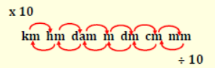

Explore:
- Introduce the story of the Gimli Glider. Essentially, back in 1983, a plane left Montreal intending to go to Edmonton. Unfortunately, they ran out of gas about halfway because the pilot converted the gas needed in pounds instead of kilograms. Canada had recently switched to using the metric system, so the pilot accidently used the wrong conversion.
- Show students the clip on the Gimli Glider. It is about 15 minutes, so parts can be cut out. It is really just an entertaining clip that explains how the pilots had to land the plane with no gas.
- Next, go through the rest of the Notebook slides. Students should figure out how much fuel they actually needed versus how much they put on the plane using the information the pilot had when he converted initially.
  - There were 7682 L already on the plane.
  - The total amount of fuel they needed was 22,300 kilograms.
  - How much fuel did they need?
    - Due to the temperature, the conversion on this date was 1L = .803 kg
  - When the pilots did their conversion, they calculated out 22,300 pounds of fuel.
    - Convert 22,300 pounds of fuel to kilograms and see how much fuel they were missing out of the 22,300 kg
- Students should work with their groups to answer the above questions. They will write their final answers on the board.
Share:
- Have groups take turns sharing their answers that they wrote on the board. Students should explain their work and show how their conversions work.
- If different groups solved the problem in different ways, they should explain their methods.
Summary:
- The lesson should end with a short discussion on how important conversions are. It would be great if everyone used the same units, but this will obviously cause issues initially as people get used to them.
- Have students think of other real world situations where a mistake in a conversion can cause a big problem. Ask students if they ever use conversions in their lives (baking and cooking is one of the biggest ones).
- By the end of these two days, students should be comfortable setting up ratios and converting between units. They should see the connection between conversions and the proportional relationships they worked with at the beginning of the unit.
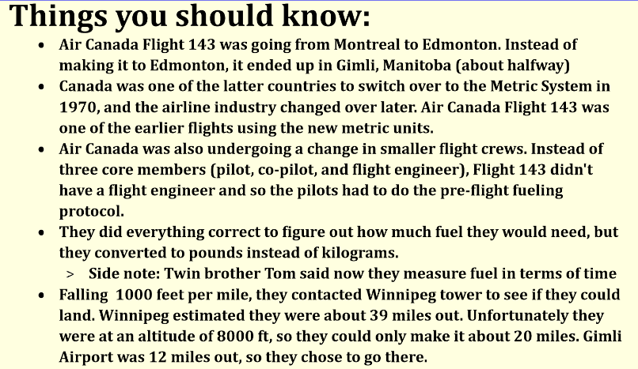

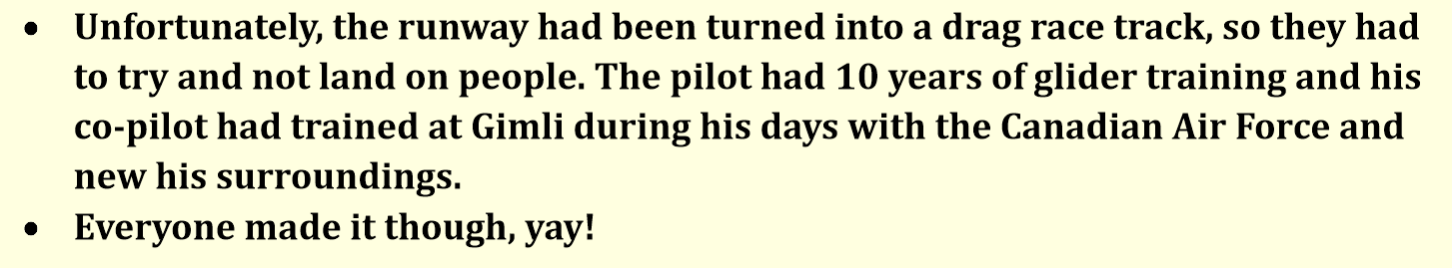

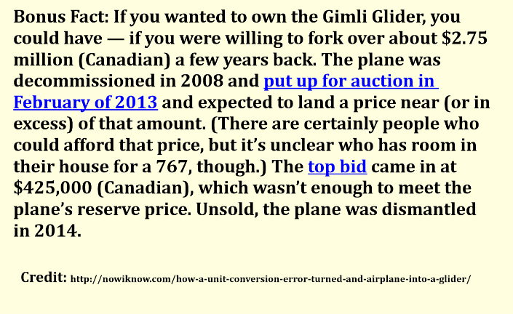
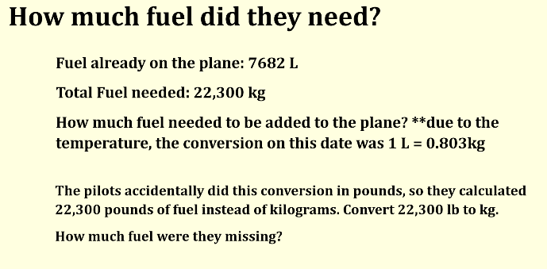

Day 12: Direct Variation

Objective: Students will use tables, graphs, and equations to identify direct variation problems
MN State Standards:
- 8.2.2.2 Identify graphical properties of linear functions including slopes and intercepts. Know that the slope equals the rate of change, and that the y-intercept is zero when the function represents a proportional relationship
- 9.2.1.8 Make qualitative statements about the rate of change of a function, based on its graph or table of values
- 9.2.4.8 Assess the reasonableness of a solution in its given context and compare the solution to appropriate graphical or numerical estimates
Materials:
- Stacking Boxes worksheet
Launch:
- Have students review different relationships that can happen between two variables by thinking of different real world examples that happen that are not linear.
  - For example, finding volume is y=x³ for a cube which is not linear
  - Some may be used to square roots, quadratic, exponential, cubic
  - Some may even mention the relationship 1/x, which is what they are discovering.
- Going into this worksheet, students should know that every relationship between two variables does not have to be linear.
Explore:
- Hand out the Stacking Boxes worksheet. Students will work in their groups through the worksheet to learn about direct variation.
- The worksheet first has students represent a situation in a table, and then it has them plot the points from the table on a graph.
  - Students should see that this graph is linear and that it is similar to the activity we did with constants of proportionality earlier in the unit.
- The rest of the worksheet gives the formal term “direct variation” and has students write an equation to represent the situation. Then they have to analyze different parts of the equation and determine what happens when different factors of the situation change.
- Once students finish the example on stacking boxes, they will fill out a Frayer Model of the term direct variation.
Share:
- Students will share their Frayer Models with the class. Overall, students should have the following information written down for notes:
  - Definition: a relationship between two variables in which one variable is equal to a constant times the other variable
  - Characteristics: as x increases y increases, this is a linear relationship that goes through the origin, the constant is known as the constant of proportionality
  - Examples: y = kx, y = 4x, y = (1/2)x, they could show an example graph of a straight line going through the origin
  - Non-examples: y = k/x, xy=k, y=x², y = 2x+1, they could show an example of a graph of anything but a straight line going through the origin
Summary:
- Students should know that direct variation is a specific type of linear equation where the line goes through the origin.
- An example of this is the activity students completed in class on Marcellus the Giant.
Copyright 2010 College Board
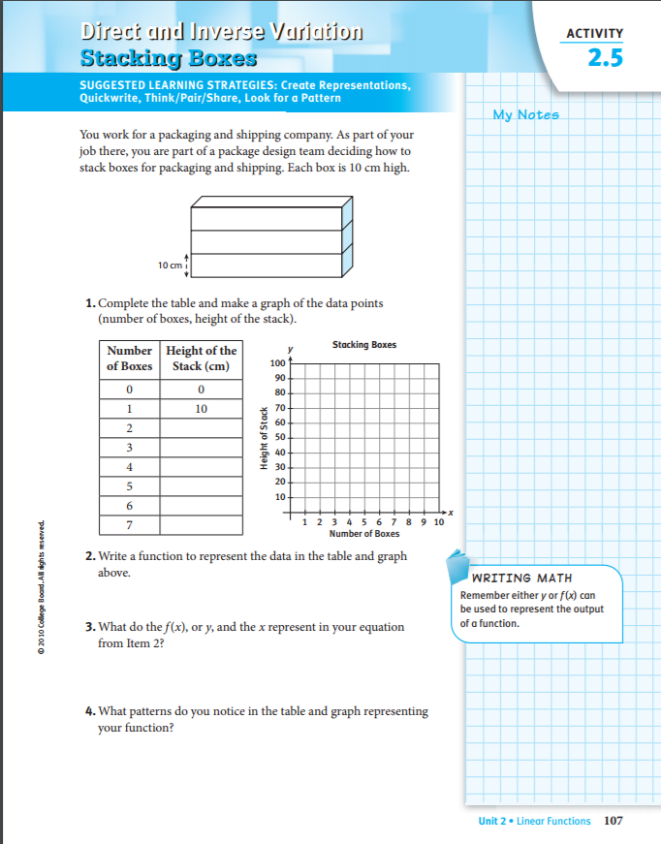

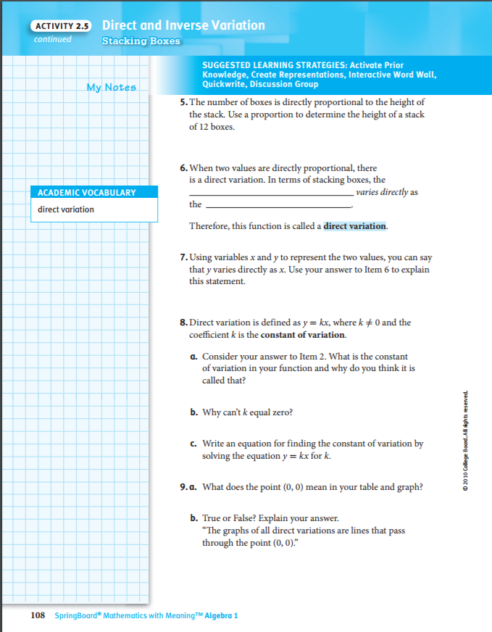

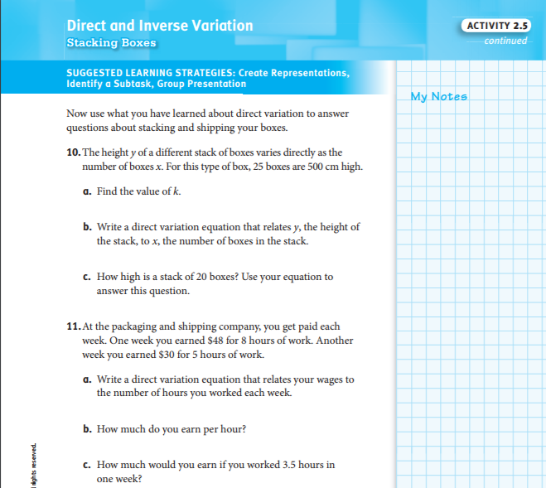

Definition Characteristics

Direct Variation
Examples Non-examples

Day 13: Inverse Variation

Objective: Students will use tables, graphs, and equations to identify inverse variation problems
MN State Standards:
- 9.2.1.8 Make qualitative statements about the rate of change of a function, based on its graph or table of values
- 9.2.4.8 Assess the reasonableness of a solution in its given context and compare the solution to appropriate graphical or numerical estimates
Materials:
- Do I Have to Mow the Whole Thing? worksheet
Launch:
- Have students graph y = 2x and y = 2x + 4 on the same coordinate plane.
  - Ask students if there are any similarities between the two. Ask them if there are any differences between the two. Are they direct variation problems? Are they linear?
  - Have them come up with a possible story problem to represent each equation.
  - Let a few students share their problems before moving on.
Explore:
- Hand out the Do I Have to Mow the Whole Thing? Worksheet. Students will work together to complete both sides of the worksheet.
- Just like the previous activity, students will come up with a table of values and then they will graph the points from their table.
  - Students should make note of any similarities or differences they see between the problems they are working on today and the one they did the previous day.
- Once students finish their worksheets, they should create a Frayer Model for inverse variation.
Share:
- Students will share their Frayer Models. The key points for their model should be:
  - Definition: a relationship between two variables in which the product is a constant
  - Characteristics: as one variable increases the other decreases, the graph is not linear
  - Examples: y=k/x, xy=k, y=4/x, xy=10, students could sketch a graph of one of the graphs from their worksheet
  - Non-examples: y=kx, y=x², students could show a graph of positive linear relationship
- There should be discussion on the main differences between direct and inverse variation.
- Ask students if they can think about any other inverse variation problems that could happen in the real world.
Summary:
- After today, students should understand that inverse variation is written as y=k/x or xy=k. With inverse variation, one variable increases while another decreases. The k value no longer acts as our constant of proportionality because our rate of change is different throughout different points in the graph.

Source: NCTM Illuminations –
Do I Have to Mow the Whole Thing?
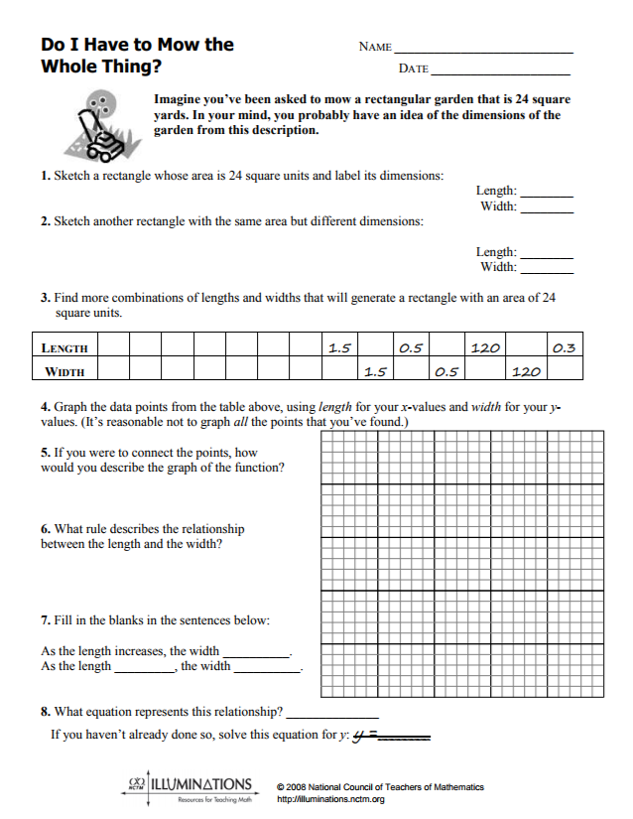

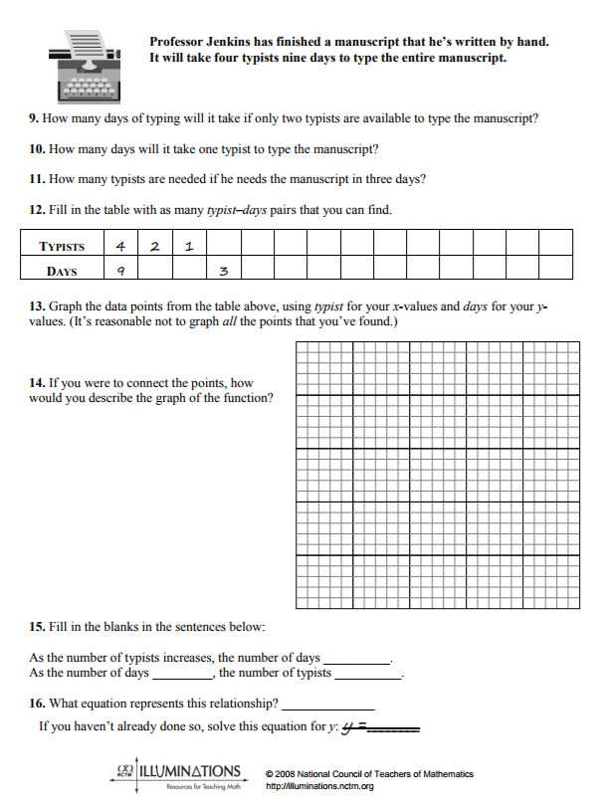

Day 14: Direct and Inverse Variation Foldable
Objective: Students will be able to represent direct and inverse variation as an equation, a table, a graph, and a word problem
MN State Standards:
- 7.2.1.1 Understand that a relationship between two variables, x and y, is proportional if it can be expressed in the form $\frac{y}{x}=k$ or $y=kx.$ Distinguish proportional relationships from other relationships, including inversely proportional relationships ($xy=k$ or $y=\frac{k}{x}$).
- 9.2.1.8 Make qualitative statements about the rate of change of a function, based on its graph or table of values
Materials:
- Scissors
- Blank Paper
- Coloring Utensils
- Direct and Inverse Variation Foldable example
Launch:
- Put the following equations on the board and have students identify them as direct variation, inverse variation or neither:
  - $y=3x+14, y=\frac{3}{x}, x+y=9, y=10x, xy=4, y=x,2y=3x,4y=x, x=\frac{y}{5}, x=\frac{7}{y}$
  - Students may find it helpful to rearrange the equations so that they are in terms of y. Go over the answers with explanations before moving on.
Explore:
- Each group will need a scissors, blank paper for every person, and coloring utensils.
- The structure of the foldable should be created as a class. Have students draw a line down the middle of their paper. They should write “Direct Variation” at the top of one side next to the line and “Inverse Variation” on the other side next to the line.
  - Notice how there are little rectangles cut out from the top of the paper so that these titles can act as tabs at the top of the folds. Students should cut these out.
  - Now they should fold in the two sides so that they meet in the middle. These are going to be the flaps that students can open up to review.
  - Along each side, students should create 4 flaps by cutting slits in the flaps and label them “Equation”, “Word Problem”, “Table”, and “Graph”.
- Once students are this far, it is their responsibility to work with their group to fill in the inside.
  - A sample is included with this lesson.
  - This foldable is meant to be a helpful tool for the students, so they should create it and write in it in a way that makes sense to them. They can also add anything else they would like on the inside if they think it will help them.
Share:
- Once students have finished creating their foldable, have different students share what theirs looks like.
  - As students are presenting their foldable, other students should be checking their word problems and graphs to make sure that they used appropriate examples.
  - This should also help students see where direct and inverse variation are seen in life.
Summary:
- Students should hold on to this foldable so that they can use it for a reference in the future.
- Have students get their foldable checked off if they are worried they put any incorrect information on it.
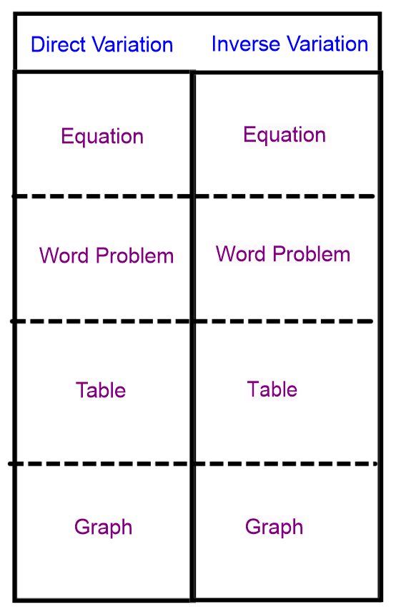

Outside

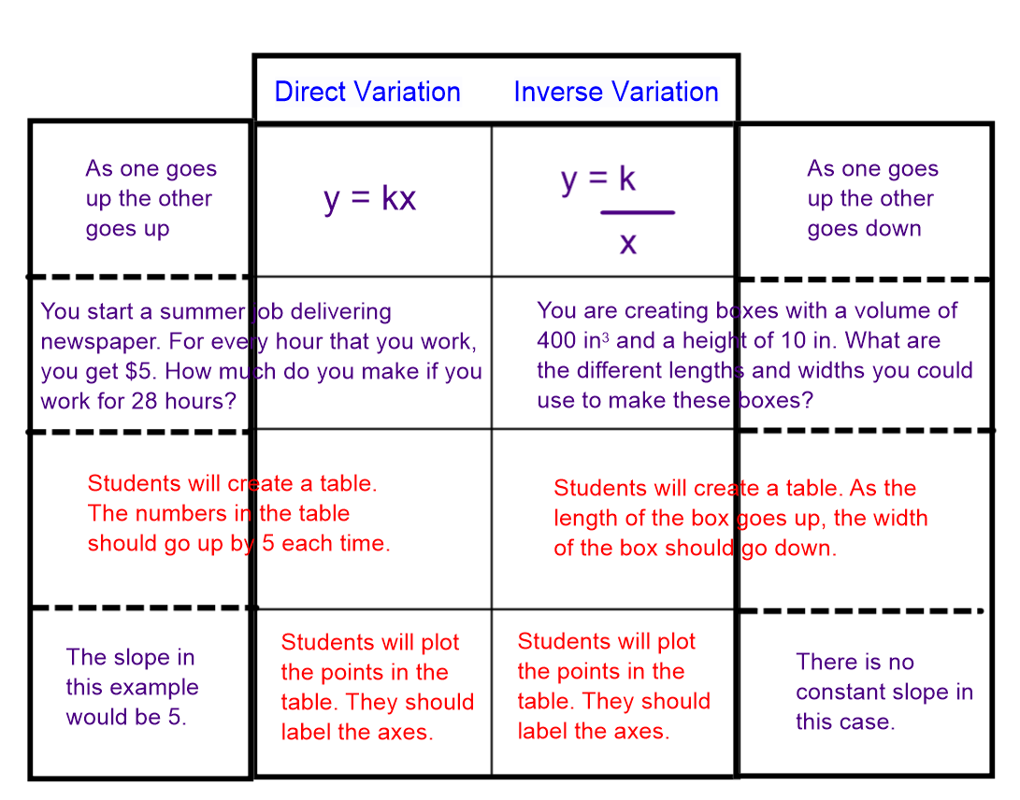

Inside – dashes are where students cut

Day 15: Direct and Inverse Variation Practice
Objective: Students will use measurement examples to identify direct and inverse variation situations
MN State Standards:
- 7.2.1.1 Understand that a relationship between two variables, x and y, is proportional if it can be expressed in the form $\frac{y}{x}=k$ or $y=kx.$ Distinguish proportional relationships from other relationships, including inversely proportional relationships ($xy=k$ or $y=\frac{k}{x}$).
- 7.3.2.3 use proportions and ratios to solve problems involving scale drawings and conversions of measurement
- 9.2.4.8 Assess the reasonableness of a solution in its given context and compare the solution to appropriate graphical or numerical estimates
Materials:
- Direct and Inverse Variation worksheet
- Rulers
Launch:
- Review conversions between units by having students convert:
  - 4.2 centimeters to meters and millimeters, 5 m to millimeters, 4.5 centimeters to inches
- Then have students think back to when they created their own island. What were some things they had to consider when creating their unit?
  - Being able to use a bigger unit in terms of a smaller unit, being able to measure small or large values, being able to measure fractional values, being able to convert between different units.
Explore:
- Hand out the Direct and Inverse Variation worksheet. Students will work through the worksheet to practice identifying direct and inverse variation situations.
- The first page of the worksheet has students measure different items in centimeters. Then they will be converting these measurements to millimeters and meters.
  - To convert to millimeters, students should be multiplying their measures by 10, and to convert to meters students should be dividing by 10, or multiplying by 1/10.
  - Then the students will have to graph. One showing the comparison between centimeters and millimeters, and the other between centimeters in meters.
  - Students should see that both are cases of direct variation because the constant of proportionality is 10 (cm to mm) and 1/10 (cm to m).
- The next page of the worksheet has students create their own units of measurement again.
  - They will be measuring the same object using their different units of measurement.
  - They will create a table and then graph the points from their table.
  - Students should realize that as their unit gets larger, the measurement gets smaller making it an inverse relationship. Because there are so few data points on the graph, it may be a little harder to see the shape, but they should notice the trend between x and y to realize it is inverse variation.
Share:
- At this point, students should be comfortable with direct variation because they are familiar with linear equations. Students should share their units of measurement from the back page so that students can see this inverse relationship works for many different situations.
Summary:
- This is the last day students will spend on direct and inverse variation. Students should be comfortable with what each equation and graph looks like.
Adapted from NCTM Illuminations – How Many Pencils Tall?

Direct and Inverse Variation
Task 1:
1. Fill out the table below by measuring each of the items in centimeters. Then convert the measurements to millimeters and meters.

Object | Measurement (cm) | Measurement (mm) | Measurement (m)
Finger
Pencil
Foot
Desk
Door
White Board

2. Graph the following below. The graph on the left should compare the measurements between centimeters and millimeters. The graph on the right should compare the measurements between centimeters and meters. Be sure to label your graph.

3. What kind of relationship does this graph 4. What kind of relationship does this graph
represent? represent?

5. In conclusion, if we use the same unit of measurement to measure everything and convert to a different unit, what kind of relationship are we using?

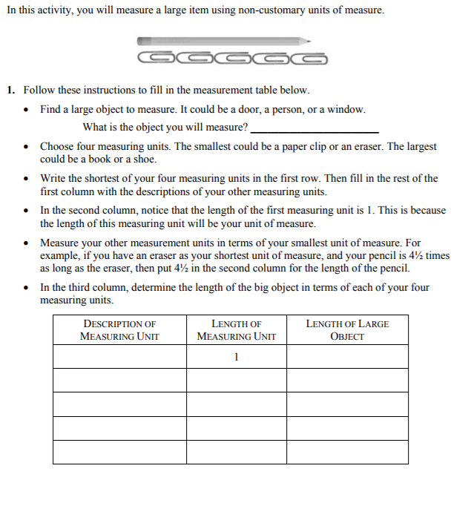
Task 2:

Graph the following. Be sure to label your graph.

2. What kind of relationship does this
graph represent?

3. In conclusion, if we measure the same object using different units, what kind of relationship are we using?

Pre/Post Test

1. You are trying to estimate the number of fish in a lake. You go to the lake and capture 35 fish. You tag these fish and release them back into the lake. A week later, you come back and capture 50 fish. Of these 50, 12 were tagged. How many fish would you estimate are in the lake?

2. You have a recipe for cookies that calls for 2 cups of flour to make 16 cookies.

a. How much flour will you need to make 64 cookies?

b. Complete the following table.

Cups of Flour | Number of Cookies
1
2 | 16
3
4
5
6
7

c. Graph the relationship below. Be sure to label your graph.
d. Is this an example of direct or inverse variation?

e. If it is direct variation, what is the constant of proportionality? (otherwise leave blank)

f. Write an equation to represent this problem.

3. You are building a rectangular garden in your backyard. You only have room for a garden with an area of 36 square feet.
a. If your garden has a length of 4 ft, what does the width have to be?

  - Complete the table to represent this situation.

Length | Width
1 | 36

c. Graph the relationship below. Be sure to label your graph.
d. Is this an example of direct or inverse variation?

e. If it is direct variation, what is the constant of proportionality? (otherwise leave blank)

f. Write an equation to represent this problem.

4. Convert the following:

a. 4.8 centimeters to millimeters

b. 98 feet to yards

c. 38 inches to centimeters

$$1cm=10mm, 1yard=3feet, 1 inch=2.54 cm$$

